ASSEMBLAGE POINT
Anatomy, Physiology, Pathology
https://whalemedical.com/how-to-locate-the-assemblage-point/

The sharp point of the arrow is touching at the X, Y coordinates.
The shaft of the arrow is indicating the Z coordinate.
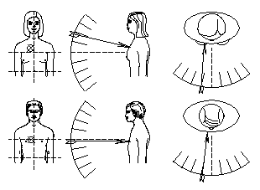
Figure 1. Average assemblage point location for male and female.

Figure 2. The ‘off centre’ map showing approximate locations for various symptoms.
(X, Y coordinates at tip/point of the arrow.)
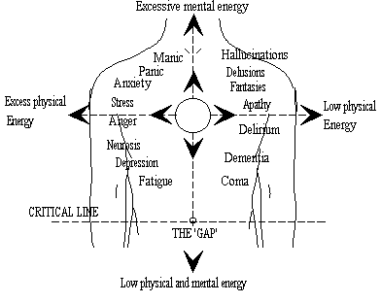
Back Left Side Back Right Side
X, Y, Z, C coordinate system
X-axis defines horizontal movement (left and right).
X-axis contains front left and right; back left and right: fr1, fr2, br1, br2; fl1, fl2, bl1, bl2, etc.
Y-axis defines vertical movement (up and down).
Y-axis contains front up and down; back up and down: fu1, fu2, bu1, bu2, etc.; fd1, fd2, bd1, bd2, etc.
Z-axis defines depth (forward/front and back). zb1, zb2, zb3, zb4, zb5, zb6; zf1, zf2, zf3, zf4, zf5, zf6
C-zero point center of grid. Center front, center back: cf1, cf2; cb1, cb2, etc
Above images by Jon Whale
Assemblage Point Pathology Assessment

Assemblage Point for: Female ☐ | Male ☐ / Whole? Yes ☐ | No ☐
Target optimal shift point Location & Entry Angle heart center and horizontal-level.
Location from absolute center of body: Back __________ Middle __________ Front ___________
Current Whole AP: shift point Front __________________________________
shift point Back __________________________________
amount off absolute center: _________________________________
Current Whole AP: entry angle point Front __________________________________
entry angle point Back __________________________________
Degrees off level at front: _________________________________
Fractures -with nodes: Front ____ Location(s), Length & Entry Angle(s)______________________
Back ____ Location(s), Length & Entry Angle(s) _____________________
Fractures - no nodes: Front ____ Location(s), Length & Entry Angle(s) ______________________
Back ____ Location(s), Length & Entry Angle(s) _____________________
Splinters (no nodes): Front ____ Location(s), Length & Entry Angle(s) ______________________
Back ____ Location(s), Length & Entry Angle(s) _____________________
Contracture(s): AP Center Front ____ length __________________________________
AP Center Back ____ length __________________________________

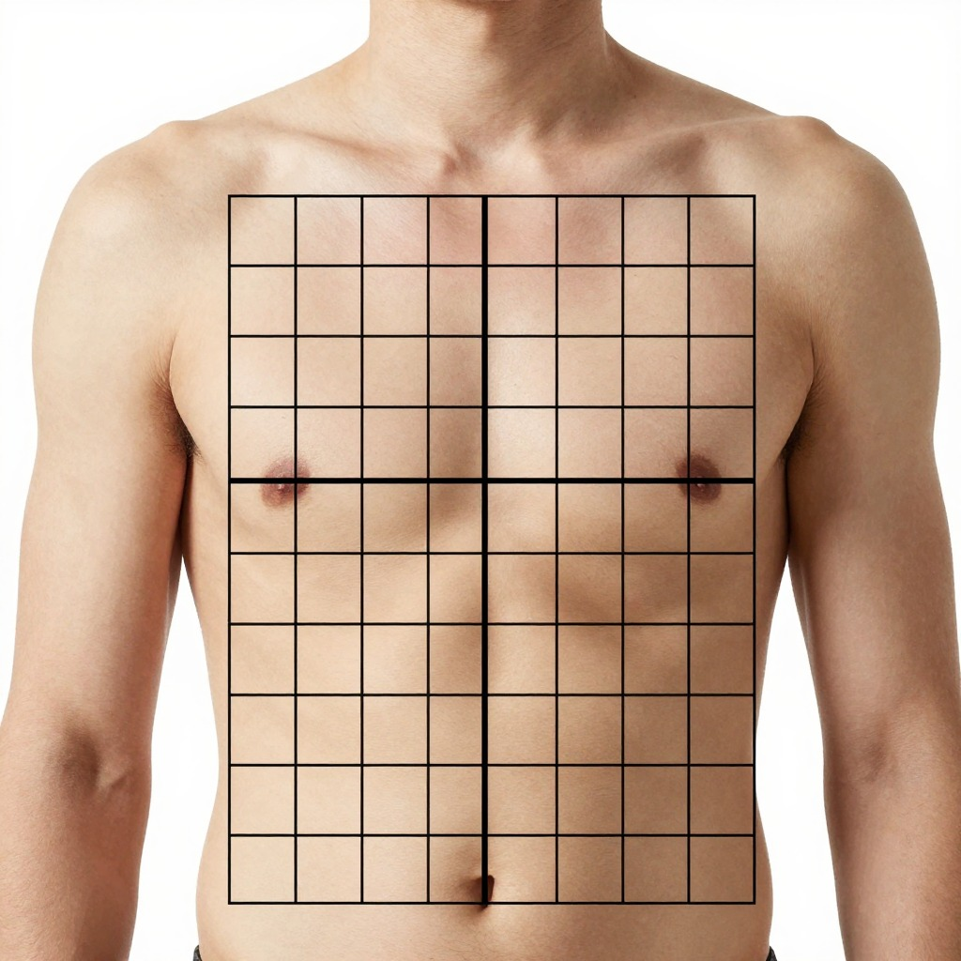

Y
u4

u3 Z

u2

u1
X r4 r3 r2 r1 l1 l2 l3 l4 X d1

Z d2

d3
d4

d5
d6
Y

Right Side Left Side

Above image by AI image generator & this author.

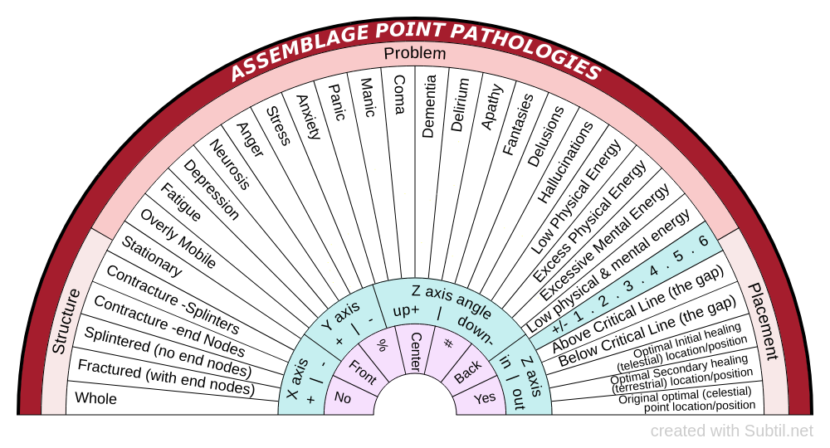

This chart created by One Last Wire,

Protocols and Techniques for Healing

Energy Medicine and Human Biofield Tuning
25 July 2026
I pulled fractured AP parts together using **Donna Eden’s way.
Then I integrate/assimilate the fractured parts together using 432 Hz tuning fork using ***Eileen McKusick’s way. Integrating the front did not integrate the back. I had to do front and back each separately.

27 July 2026
Half of the splinters integrated on their own while I slept.

27 and 28 July 2026
I did more gathering of my assemblage point parts and integrating them using my tuning fork. It sounds complicated but it’s actually pretty easy.

EFT (tapping) Protocol to shift and level the Assemblage Point*

Set up: rub sore spot and repeat three times, “Even though I have this assemblage point not at heart center problem I deeply and completely love and accept myself.”
Round 1: “This AP not at heart center problem.”
Round 2: “Still some AP not at heart center problem.”
Round 3+: “Still some remaining AP not at heart center problem.” Continue until one can perceive the shift, if it hasn’t already done so.

Set up: rub sore spot and repeat three times, “Even though I have this AP not at horizontal and level problem I deeply and completely love and accept myself.”
Round 1: “This AP not horizontal and level problem.”
Round 2: “Still some AP not horizontal and level problem.”
Round 3+: “Still some remaining AP not horizontal and level problem.”

These can be combined as such:
Set up: Even though I have this AP not at heart center and horizontal and level problem.”

If there are resistances to the shift than address those here before sealing the AP in place.

Then I sealed the AP in position with:
Round 1: “I seal the AP at heart center in horizontal and level position.”
Rounds 2 and 3 until indication of completeness.

*This is written with the consideration that the Emotional Freedom Technique protocol, as taught by Gary Craig, has already been learned. If this is not the case then please refer to
http
for your introduction and tutorials on how to perform EFT and to download the EFT manual. All free on this site.
**Donna Eden’s way-
***Eileen McKusick’s way.
I got my tuning forks from SWB 256 Tuning Forks
email: tuning@swb256.com, www.swb256.com

